System testing appendix

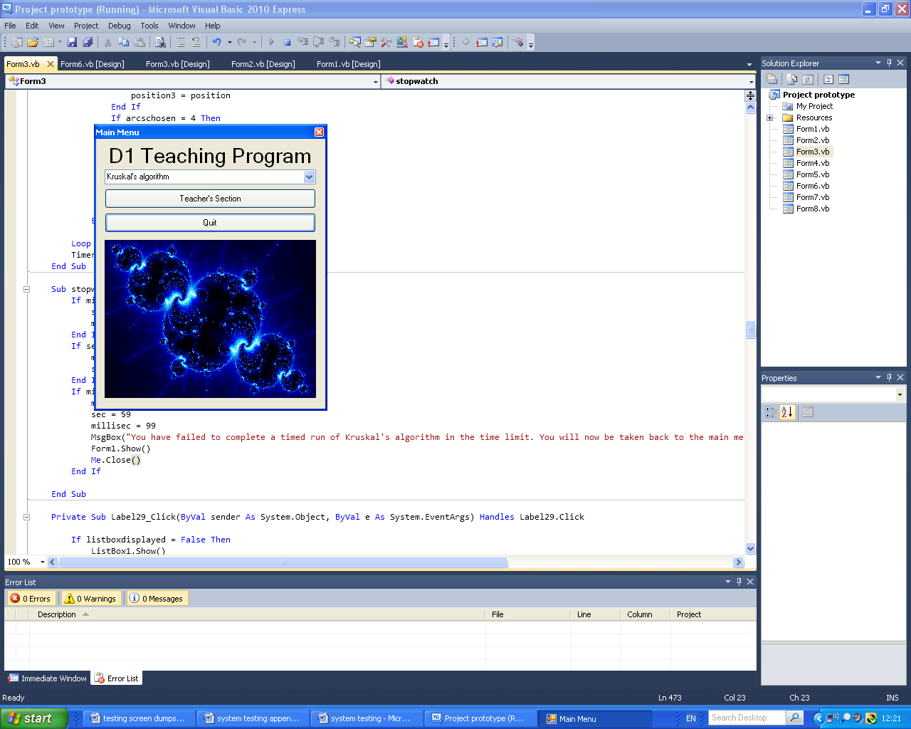Below is the Main Menu that is displayed when the program is started and therefore is te first form seen before any of the tests below are carried out:

This is the combo box that contains the choices that the user can choose to do of Kruskal’s algorithm, these being “Run”, “Timed run” and “Times achieved”.

This is the button that takes the user to the Teacher’s Section when pressed.

This is the button that exits the program when pressed.

Fig.1.1a:

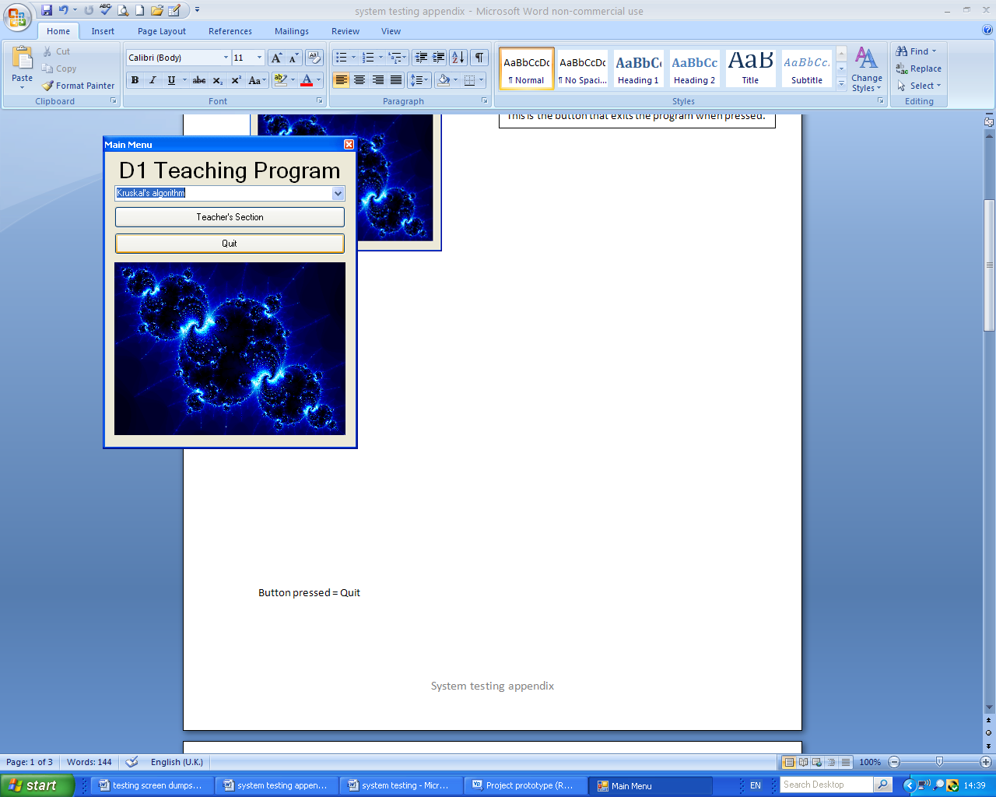 Before test: After test:

This is what is shown by the program once you have pressed the “Quit” button. (Nothing)

This is the button I pressed to begin the test.

These screen captures show that test 1.1 using the test data (Button pressed = Quit) outlined in the test plan has discovered that the program is working correctly in this case.

Fig.1.1b:

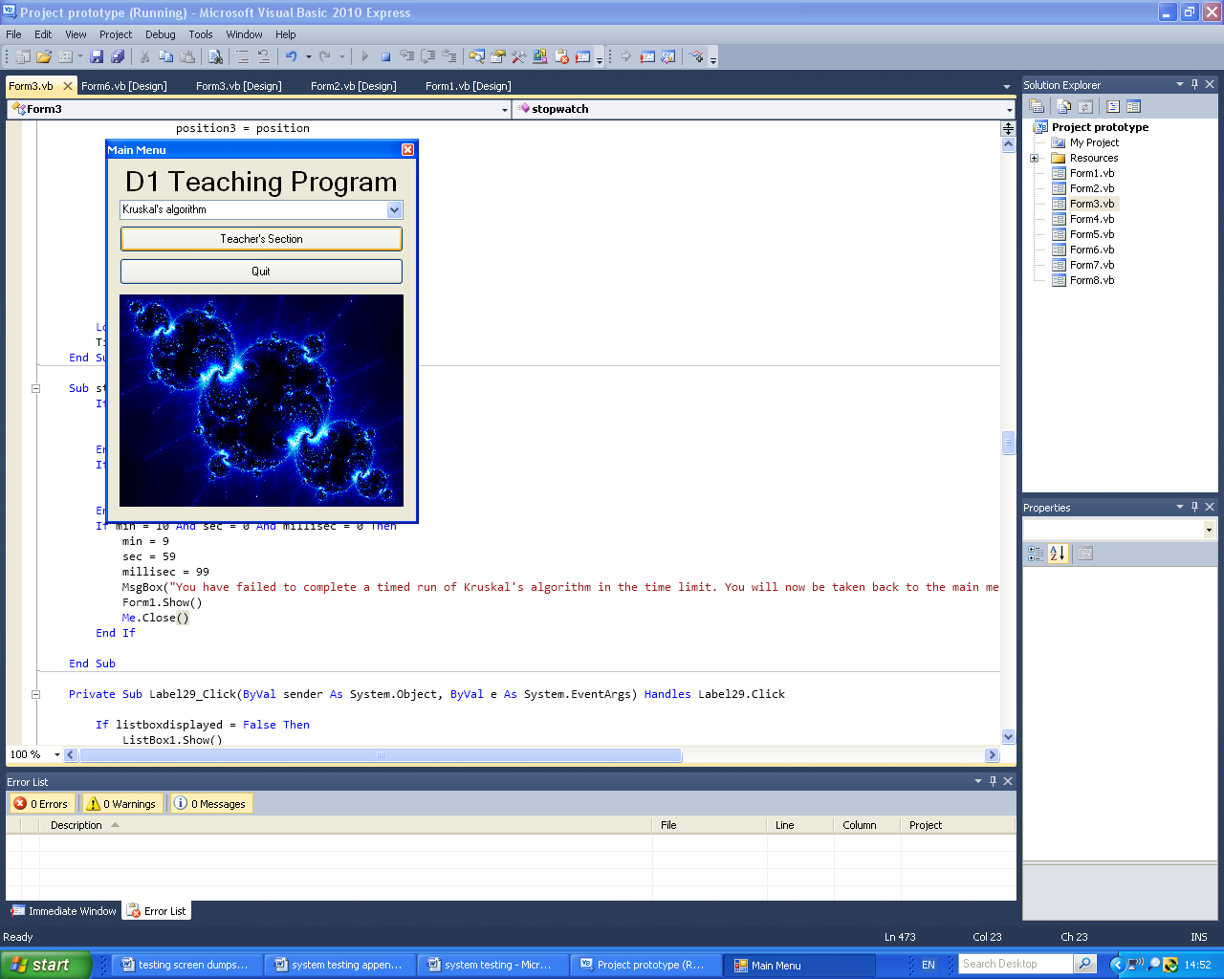 Before test: After test:

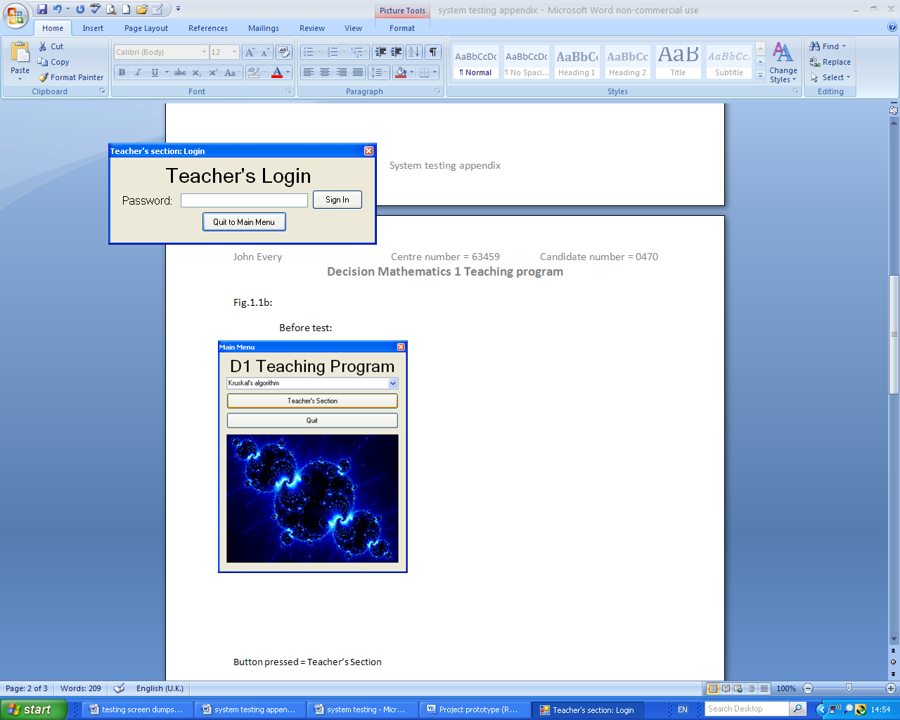

This is the “Teacher’s section: Login” page; which was displayed after I pressed the button.

This is the button I pressed to begin the test.

These screen captures show that test 1.1 using the test data (Button pressed = Teacher’s Section) outlined in the test plan has discovered that the program is working correctly in this case.

This is the option I pressed to begin the test.

Fig.1.1c:

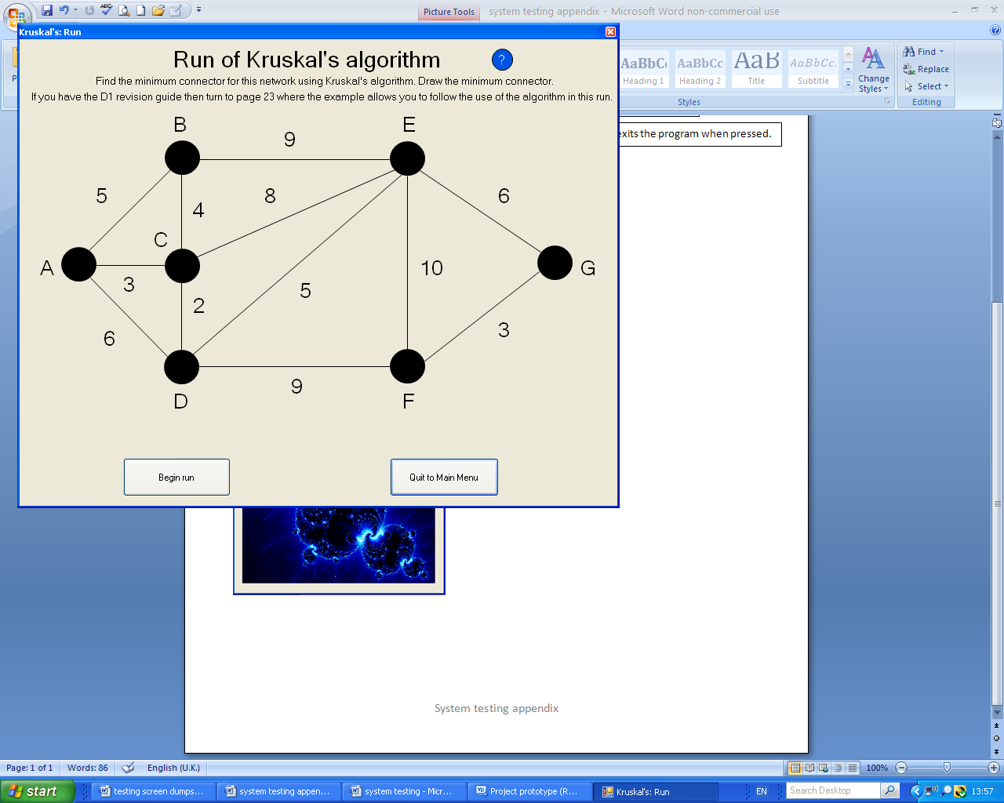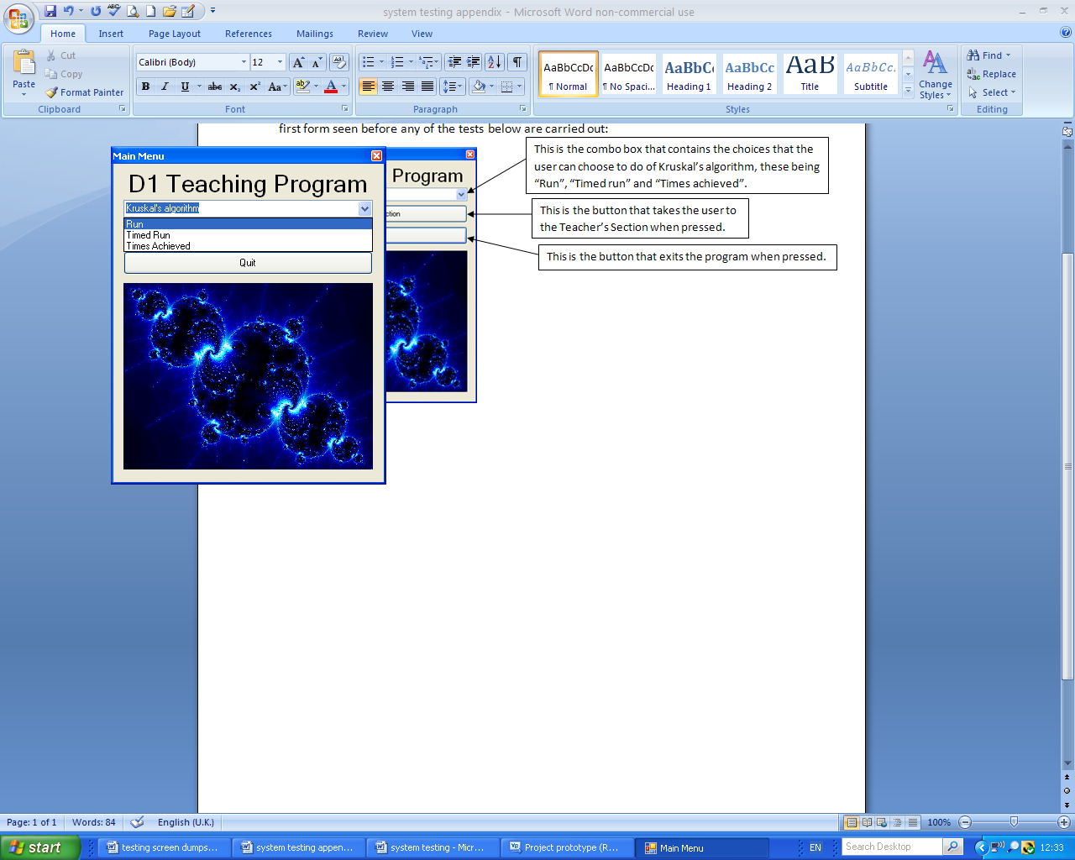 Before test: After test:

This is the “Kruskal’s: Run” page; which was shown once I had selected the option.

These screen captures show that test 1.1 using the test data (Kruskal’s algorithm combo box item chosen = Run) outlined in the test plan has discovered that the program is working correctly in this case.

This is the “Kruskal’s: Timed run” page; which was display once I had selected the option.

This is the option I selected to begin the test.

Fig.1.1d:

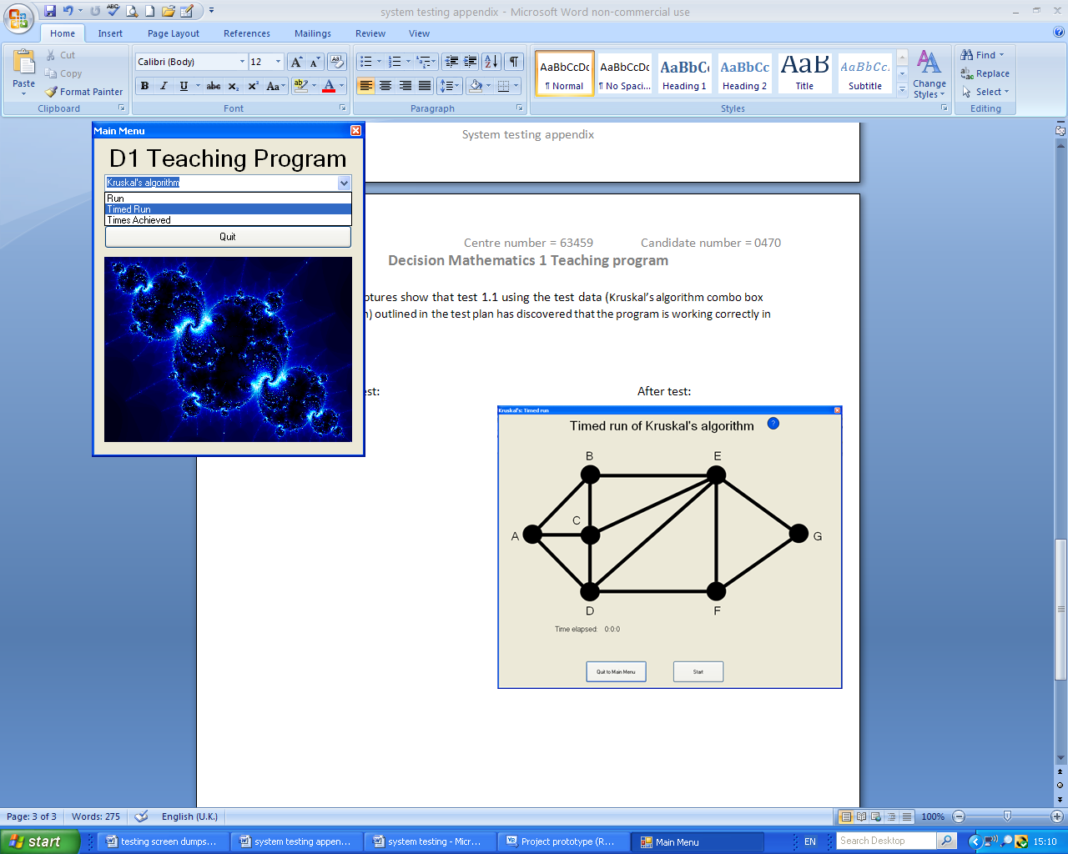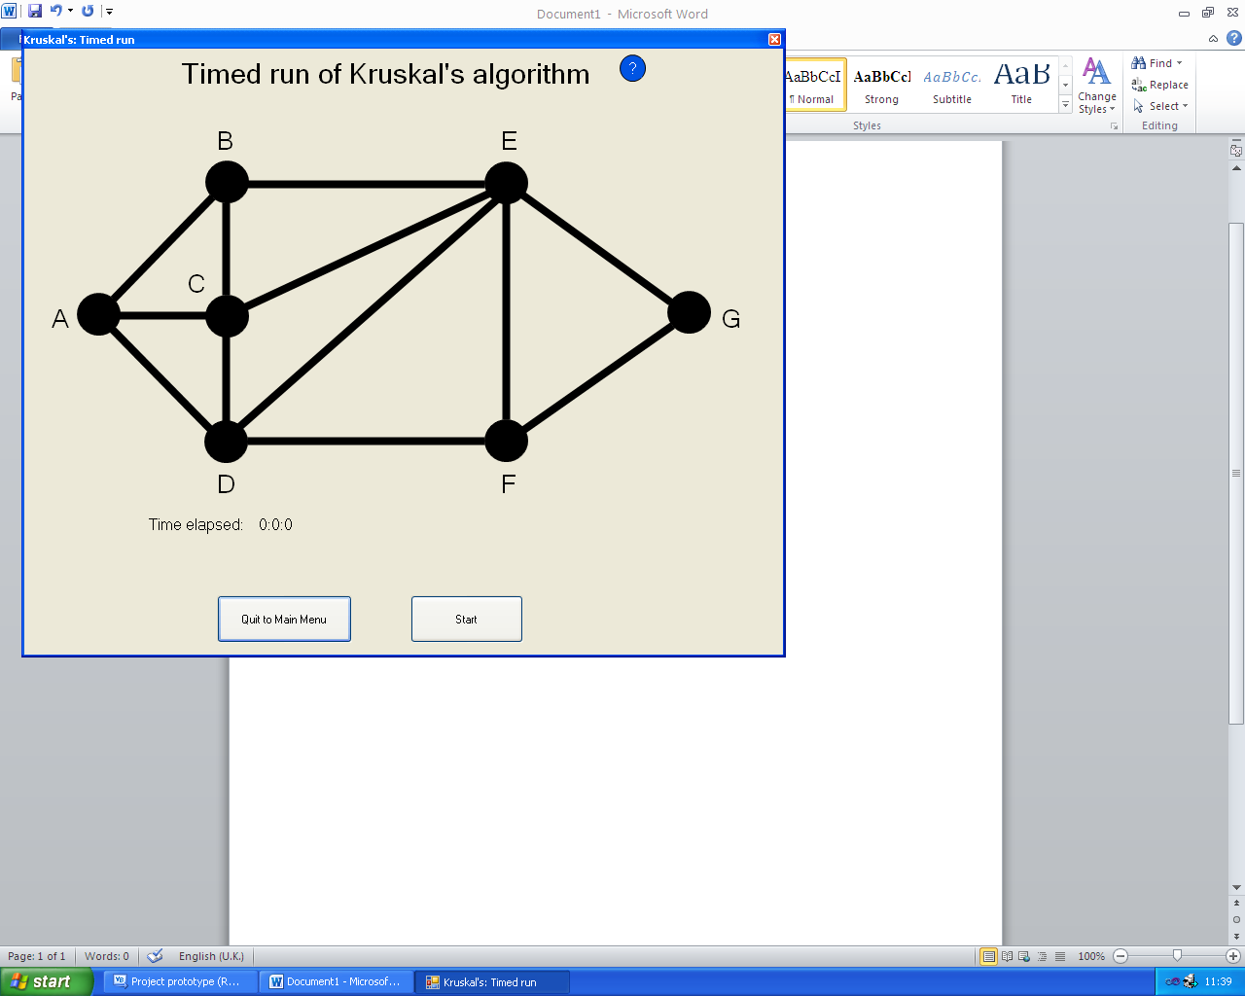Before test: After test:

These screen captures show that test 1.1 using the test data (Kruskal’s algorithm combo box item chosen = Timed run) outlined in the test plan has discovered that the program is working correctly in this case.

This is the “Kruskal’s: Times achieved” page; which was displayed once I had selected the option.

Fig.1.1e:

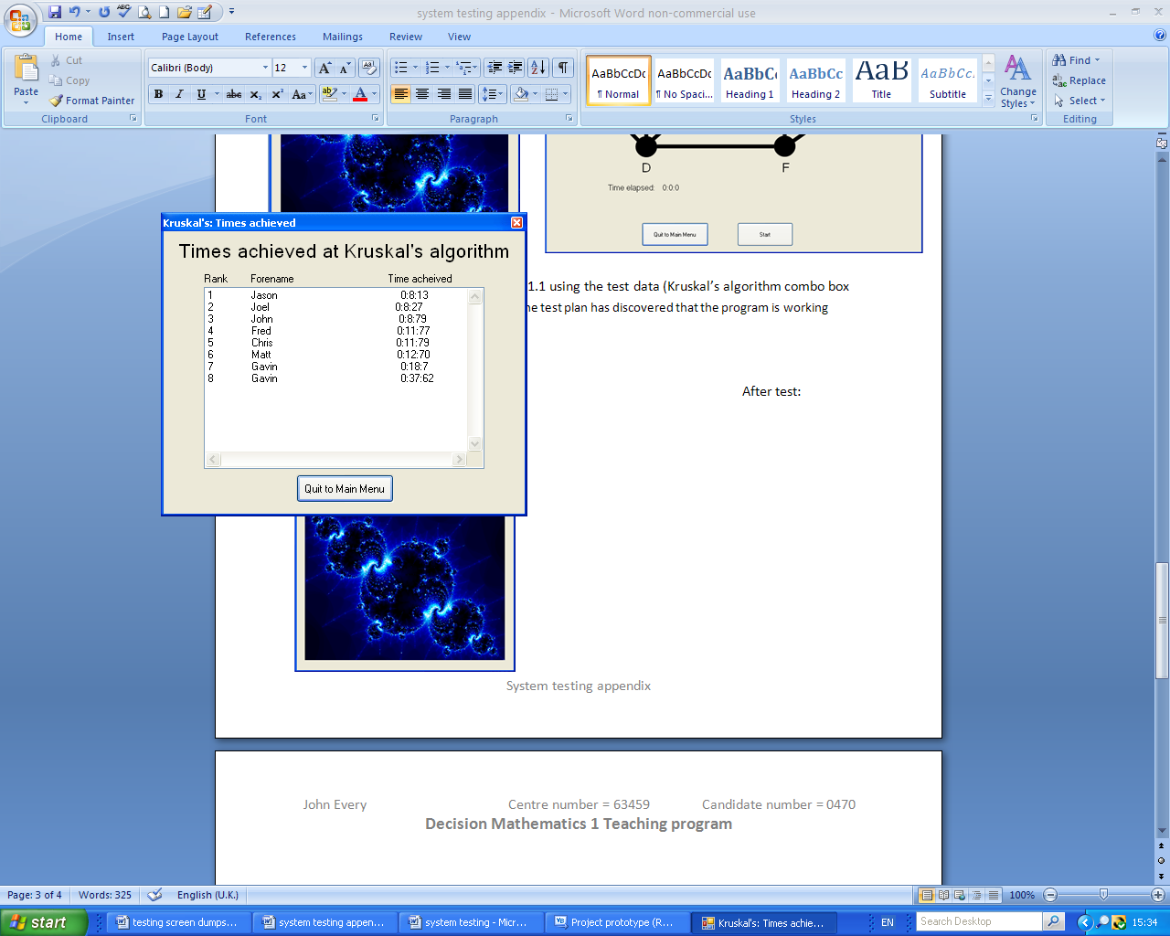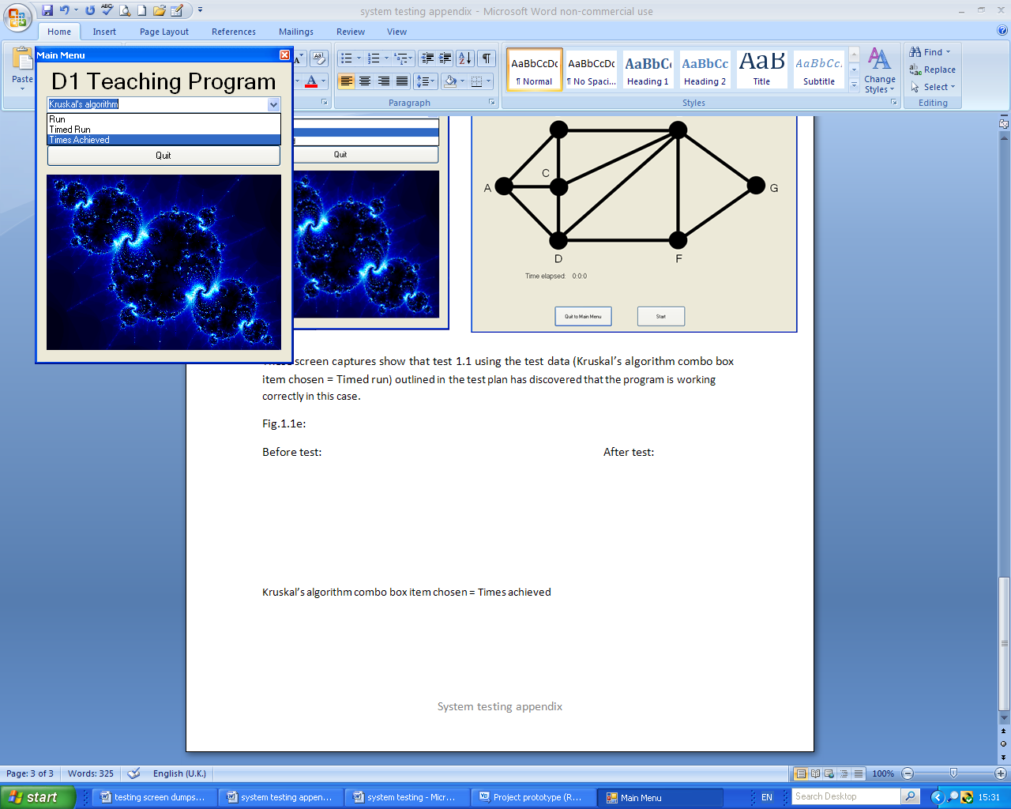 Before test: After test:

This is the option I selected to begin the test.

These screen captures show that test 1.1 using the test data (Kruskal’s algorithm combo box item chosen = Times achieved) outlined in the test plan has discovered that the program is working correctly in this case.

Fig.1.2a:

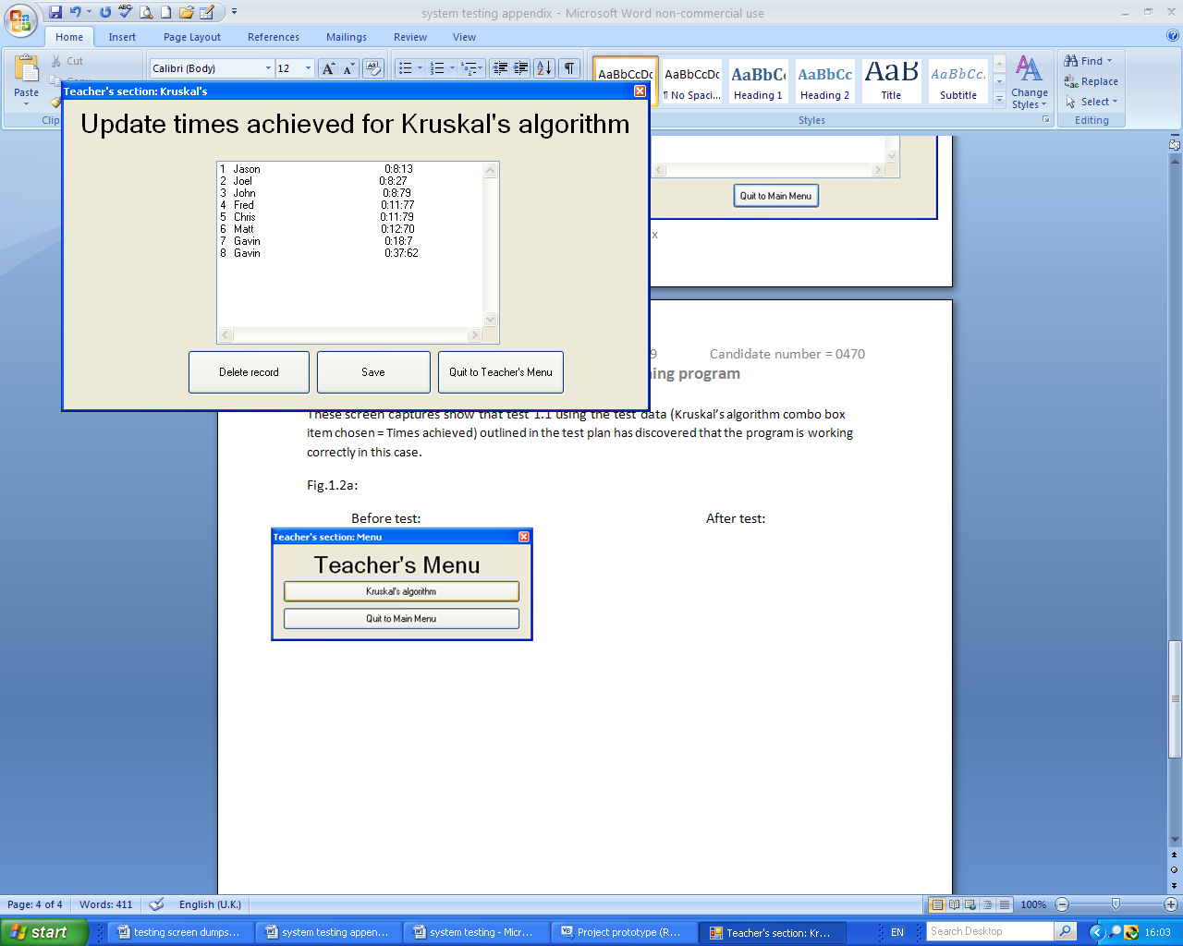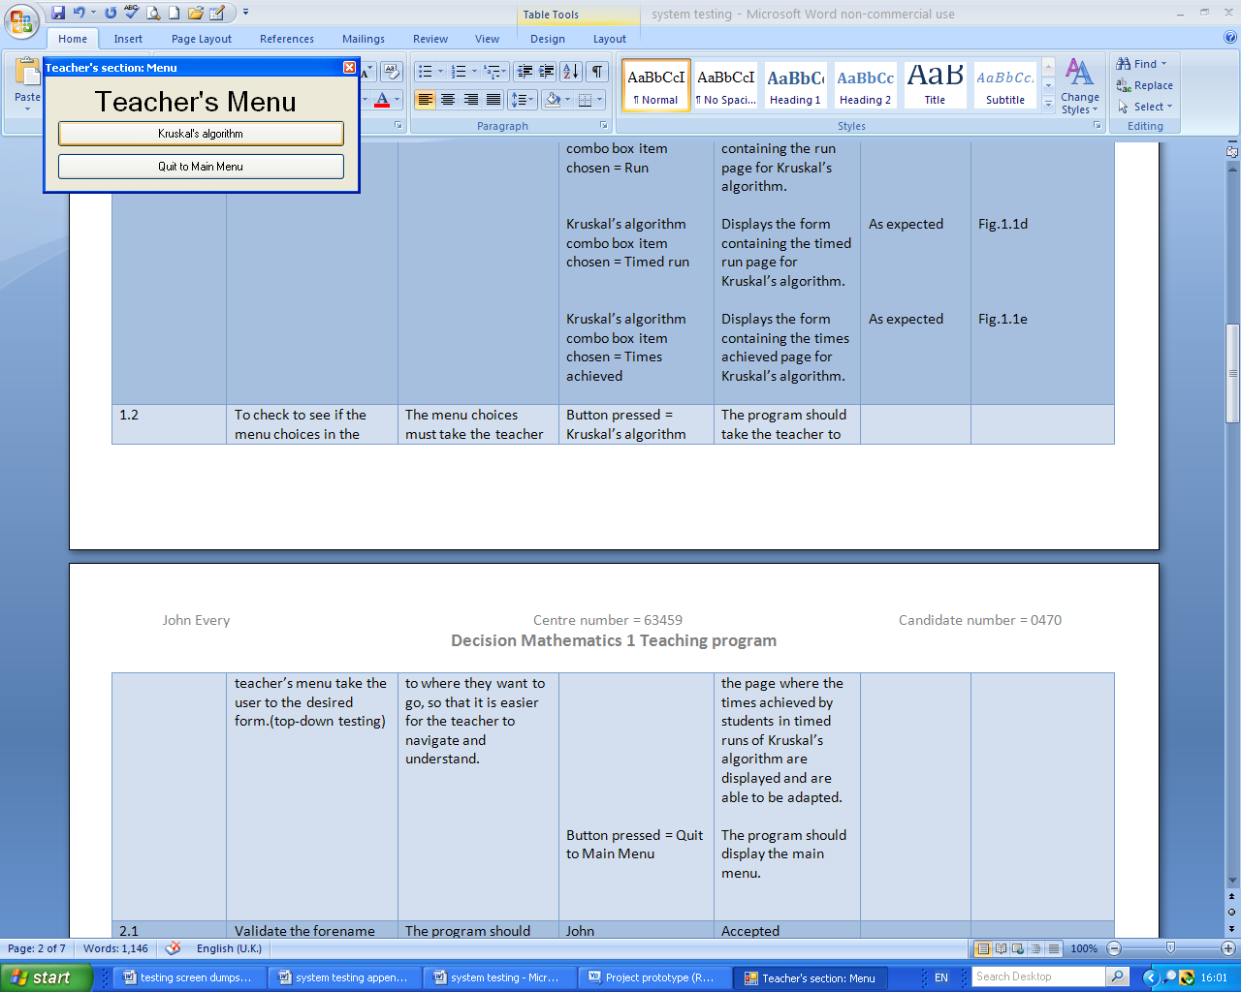Before test: After test:

This is the “Teacher’s section: Kruskal’s” page; which was displayed after I had pressed the button.

This is the button I pressed to begin the test.

These screen captures show that test 1.2 using the test data (Button pressed = Kruskal’s algorithm) outlined in the test plan has discovered that the program is working correctly in this case.

Fig.1.2b:

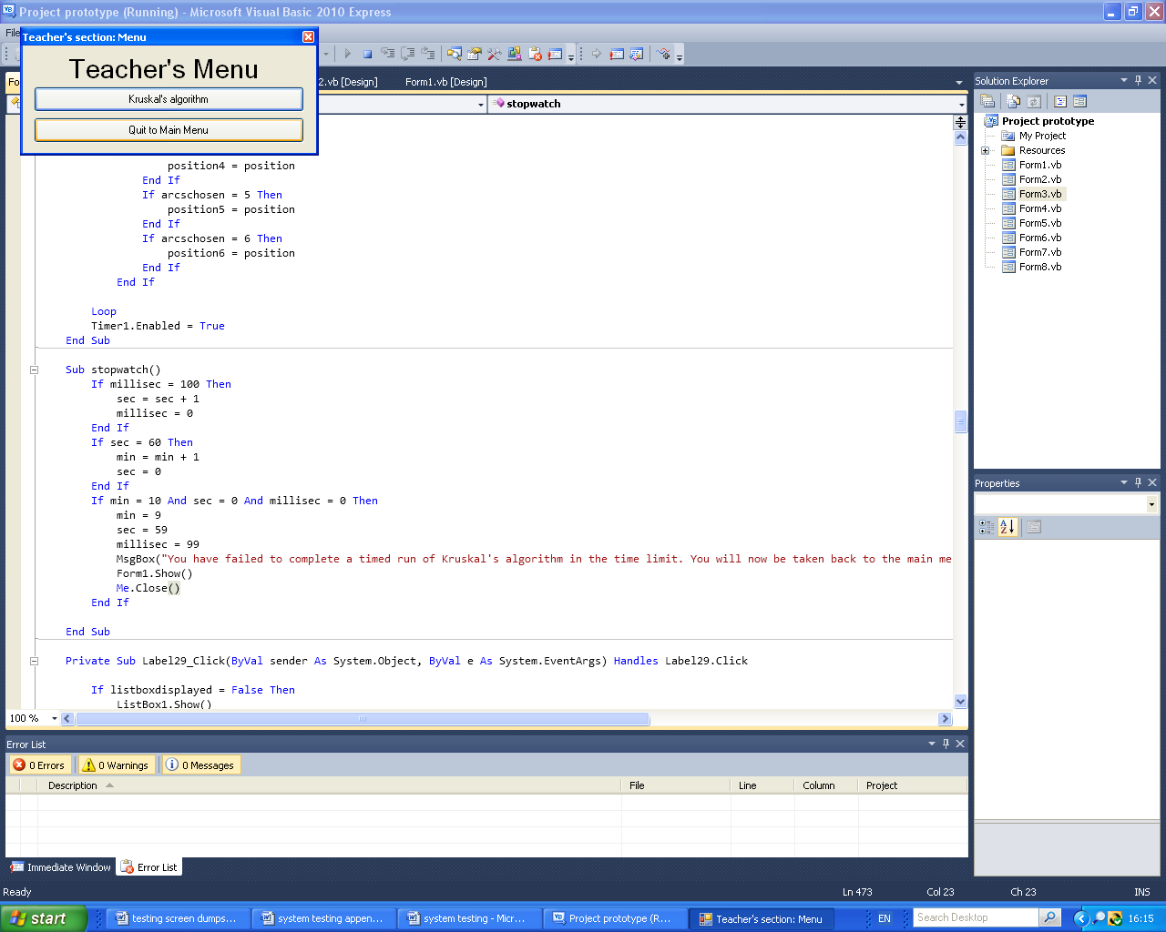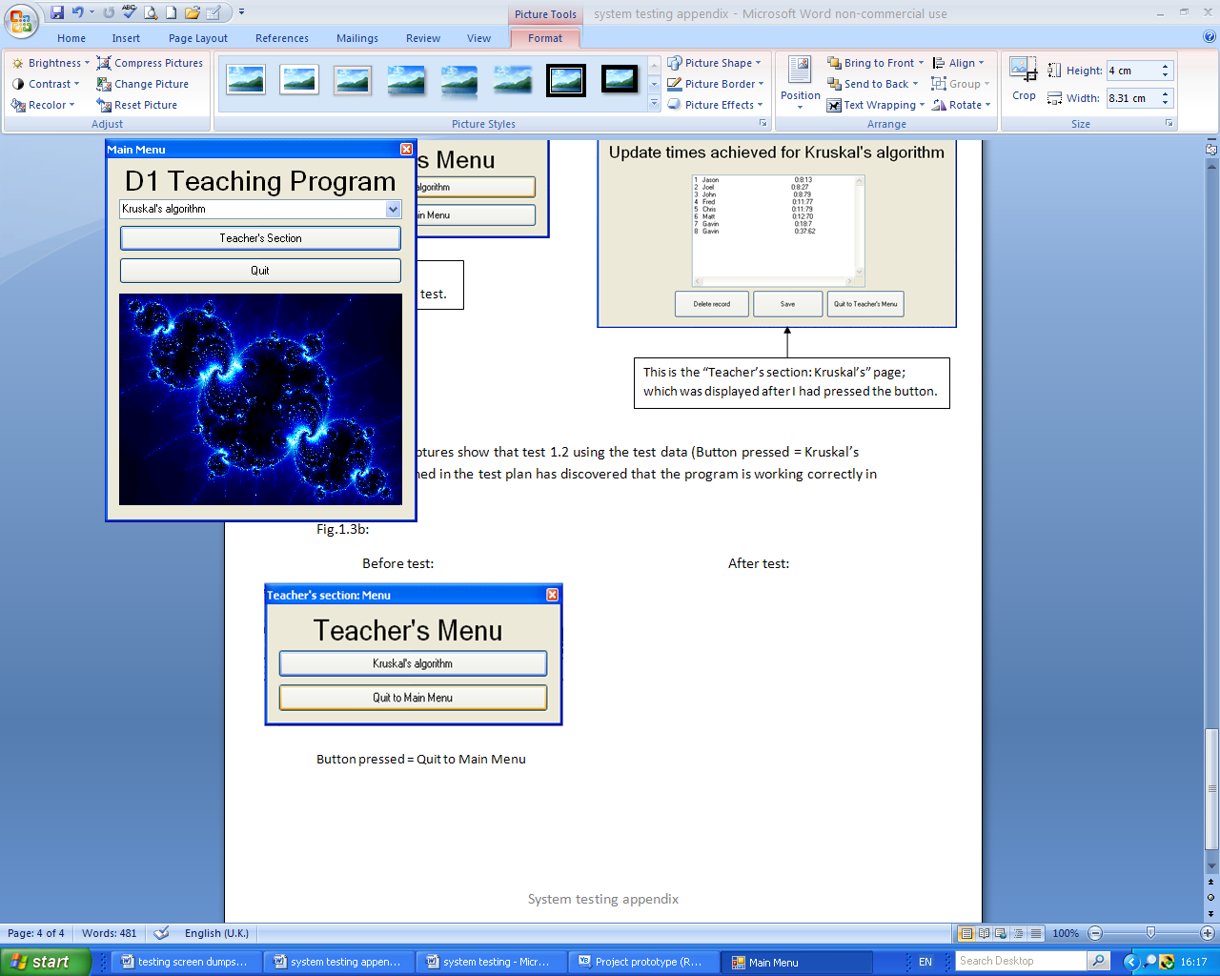 Before test: After test:

This is the “Main Menu” page; which was displayed after I had pressed the button.

This is the button I pressed to start the test.

These screen captures show that test 1.2 using the test data (Button pressed = Quit to Main Menu) outlined in the test plan has discovered that the program is working correctly in this case.

Fig.2.1a:

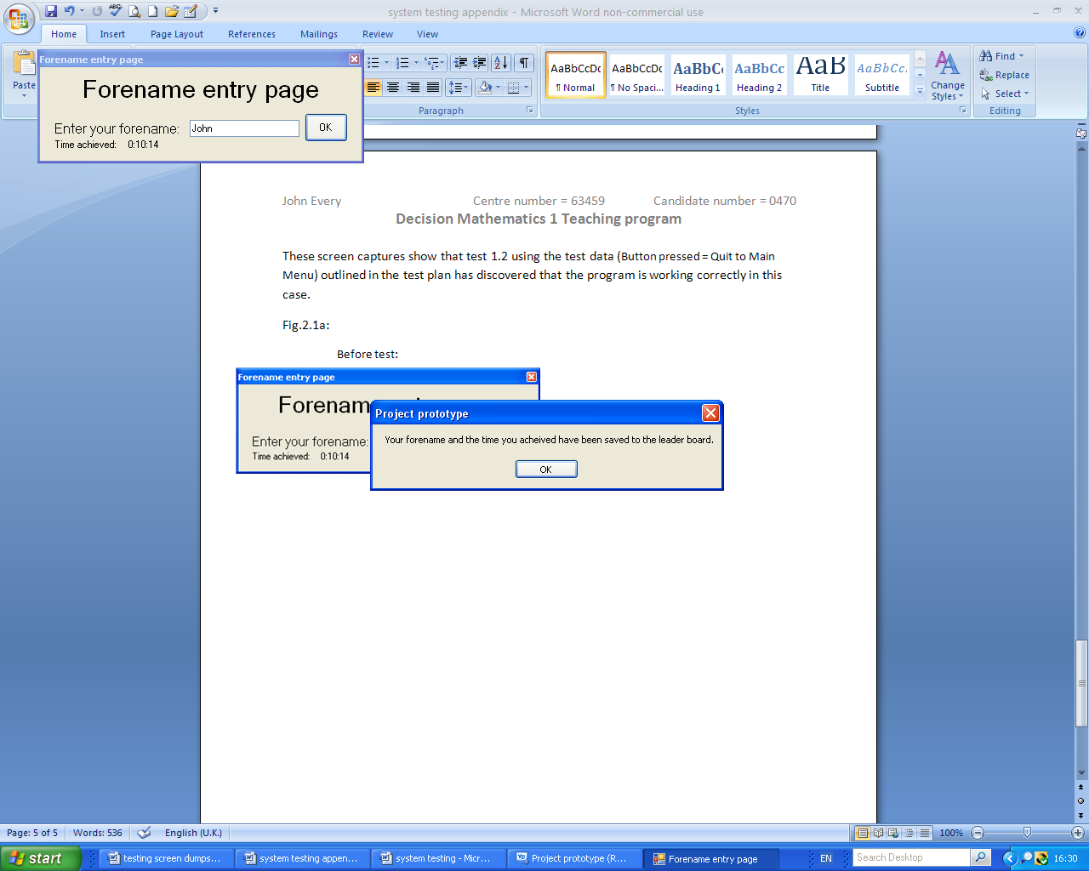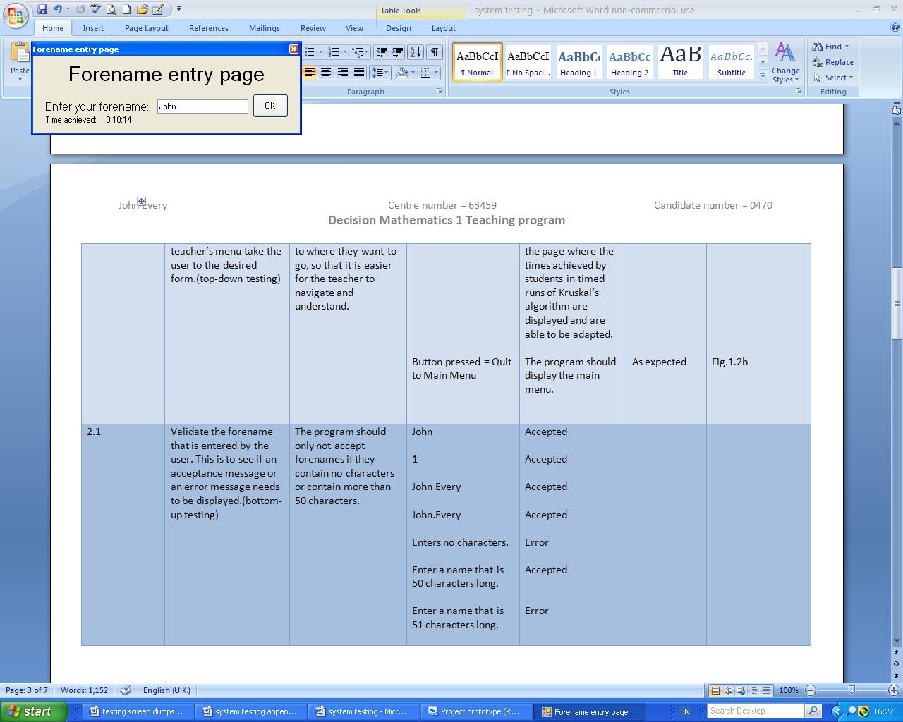 Before test: After test:

This is the message box that appeared once I had pressed the button. The text in it shows that the test data entered has been accepted.

This is the button that I pressed to begin the test.

Before beginning the test I entered the test data in to the text box.

These screen captures show that test 2.1 using the test data (“John”) outlined in the test plan has discovered that the program is working correctly in this case; because the forename entered was accepted.

Fig.2.1b:

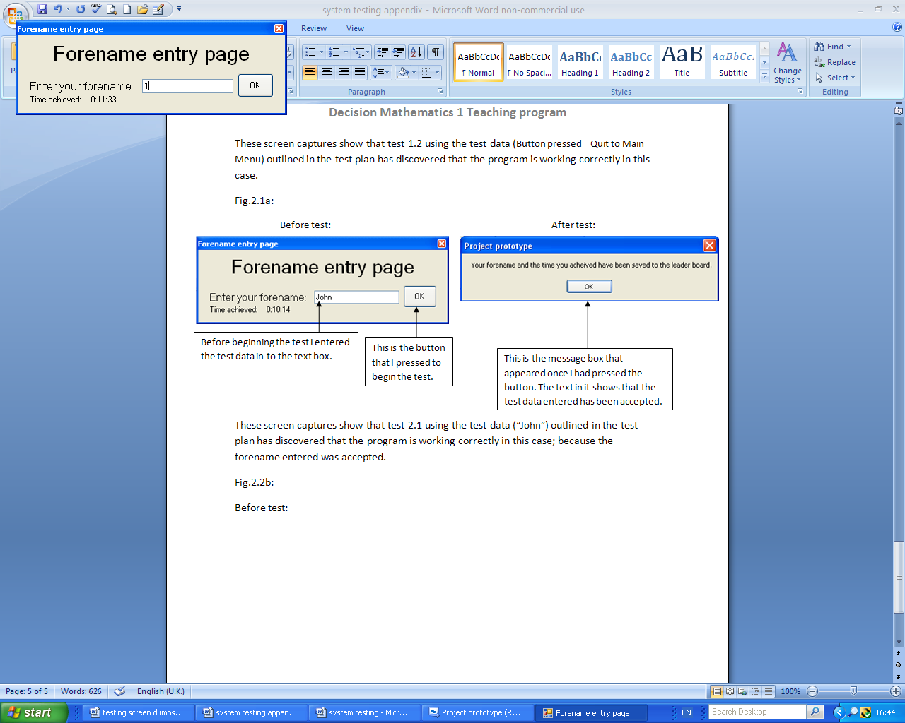 Before test: After test:

This is the message box that appeared once I had pressed the button. The text in it shows that the test data entered has been accepted.

These screen captures show that test 2.1 using the test data (“1”) outlined in the test plan has discovered that the program is working correctly in this case; because the forename entered was accepted. This is to show that my program will accept numbers into forenames so that users can enter an internet name instead of their forename.

Fig.2.1c:

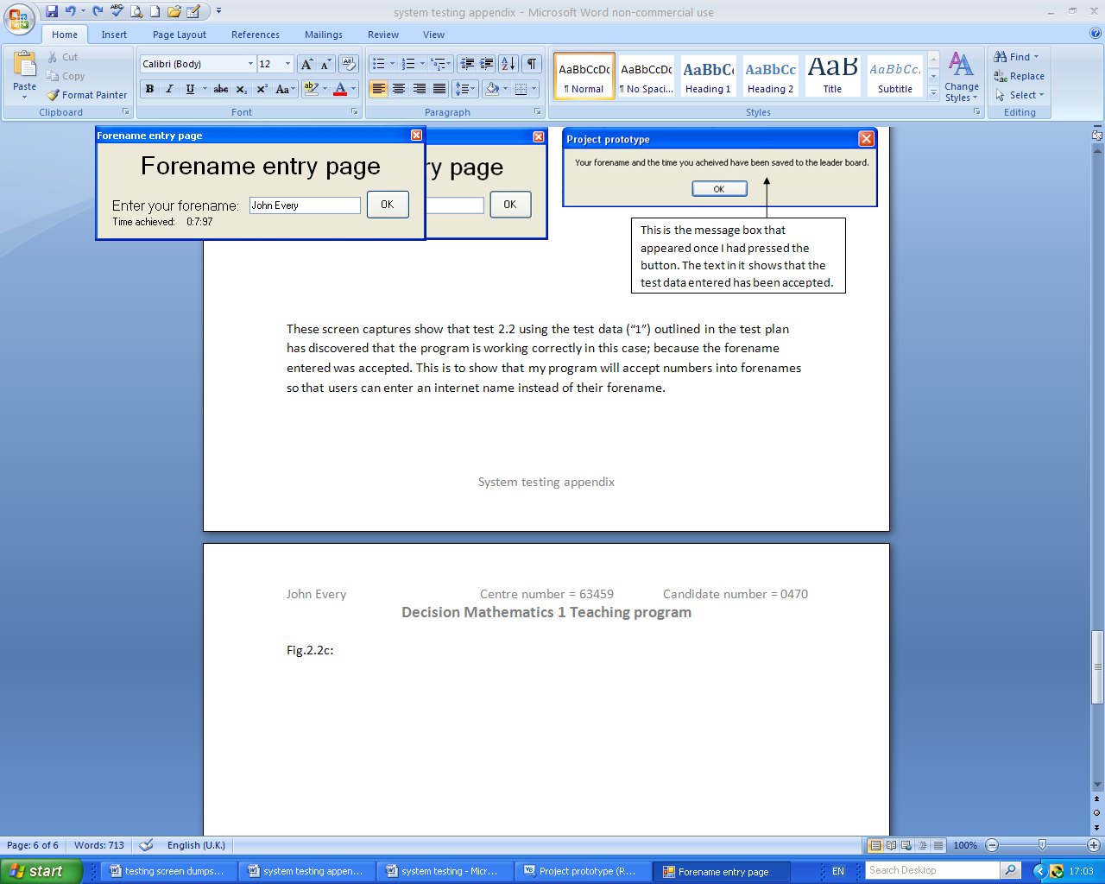 Before test: After test:

This is the message box that appeared once I had pressed the button. The text in it shows that the test data entered has been accepted.

These screen captures show that test 2.1 using the test data (“John Every”) outlined in the test plan has discovered that the program is working correctly in this case; because the forename entered was accepted. This is to show that my program will accept spaces so that users can enter their surnames if they want to.

Fig.2.1d:

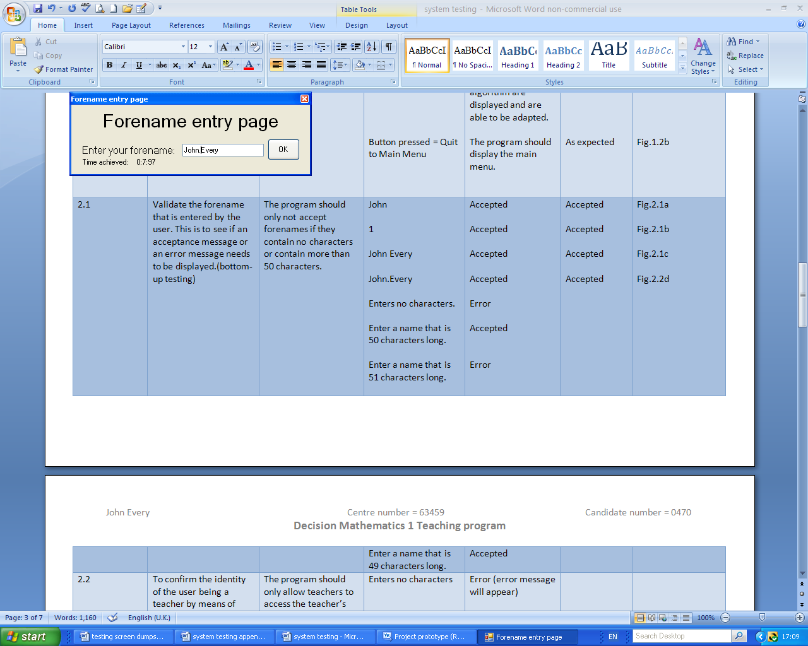 Before test: After test:

This is the message box that appeared once I had pressed the button. The text in it shows that the test data entered has been accepted.

These screen captures show that test 2.1 using the test data (“John.Every”) outlined in the test plan has discovered that the program is working correctly in this case; because the forename entered was accepted. This is to show that my program will accept punctuation so that users can enter their surnames if they want to or internet names or to just distinguish themselves from others with the same name.

Fig.2.1e:

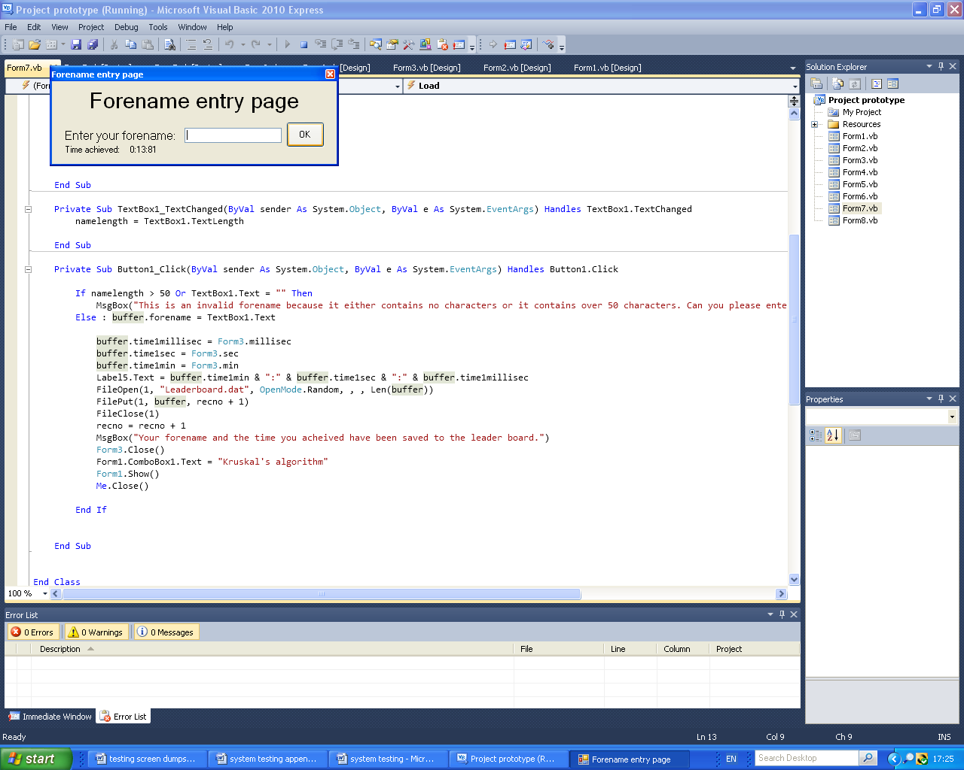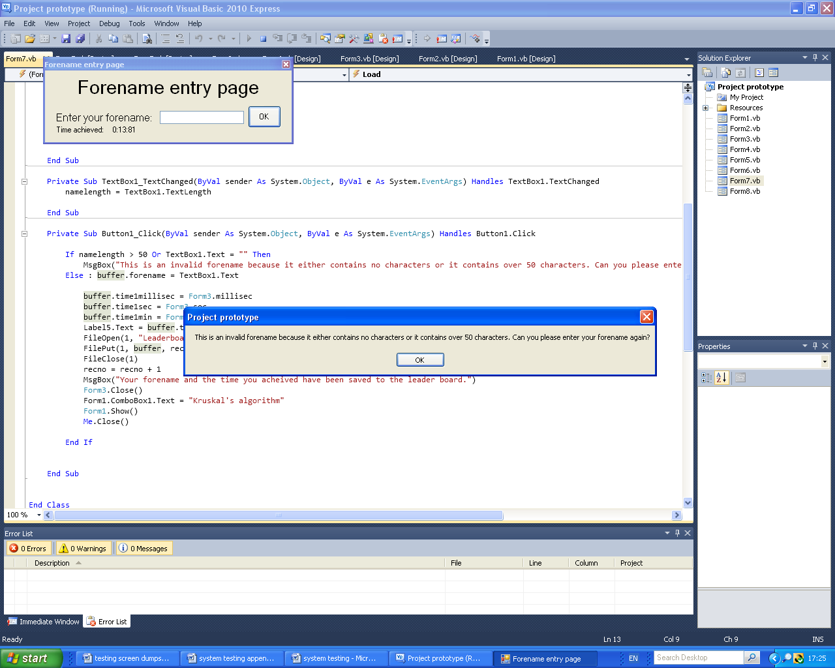Before test: After test:

I entered no characters and I pressed this button.

This is the message box that appeared once I had pressed the button. The text in it shows that the test data entered has not been accepted.

These screen captures show that test 2.1 using the test data (“”) outlined in the test plan has discovered that the program is working correctly in this case; because the forename entered wasn’t accepted and produce an error message.

Fig.2.1f:

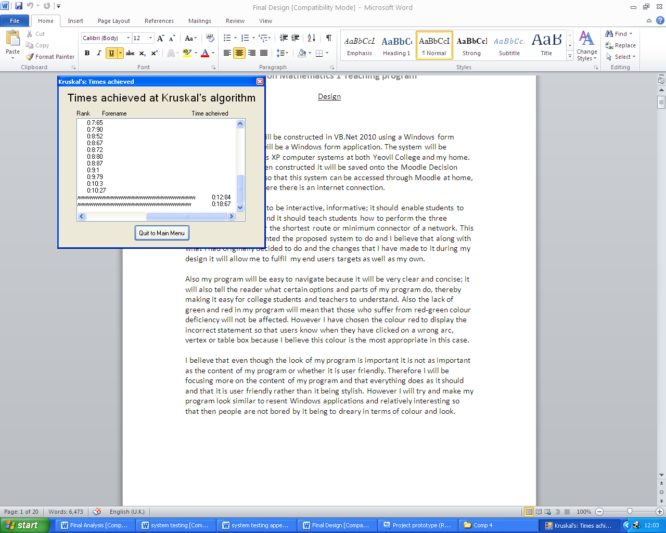Results of test:

These screen captures show that test 2.1 using the test data (“50 and 49 characters”) outlined in the test plan has discovered that the program is working correctly in this case. However the forenames entered are so large that the time achieved that corresponds to both is out of line with the others; this will need to be changed to make it look better.

Fig.2.2a:

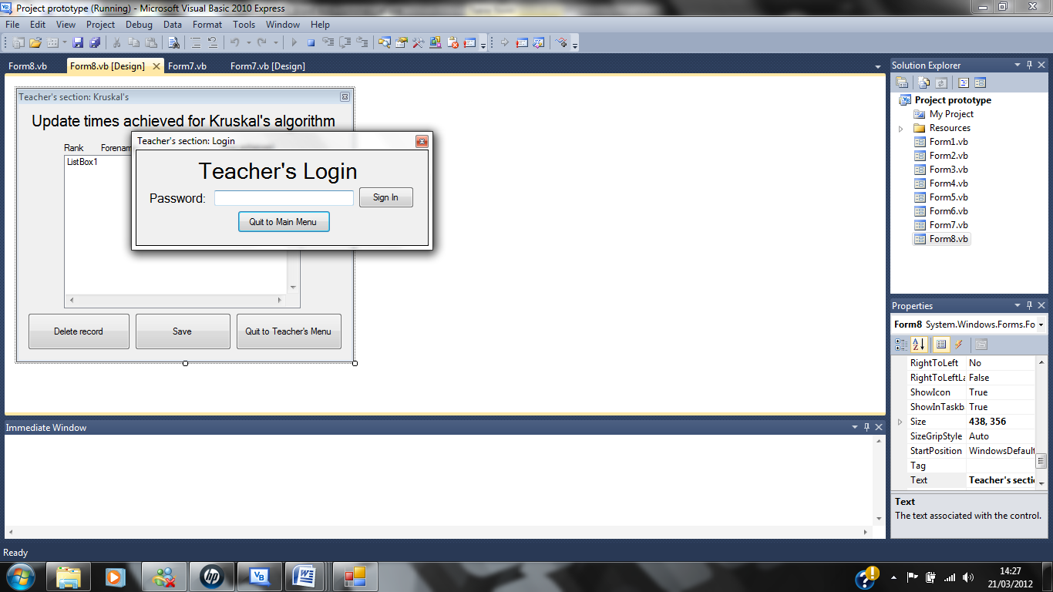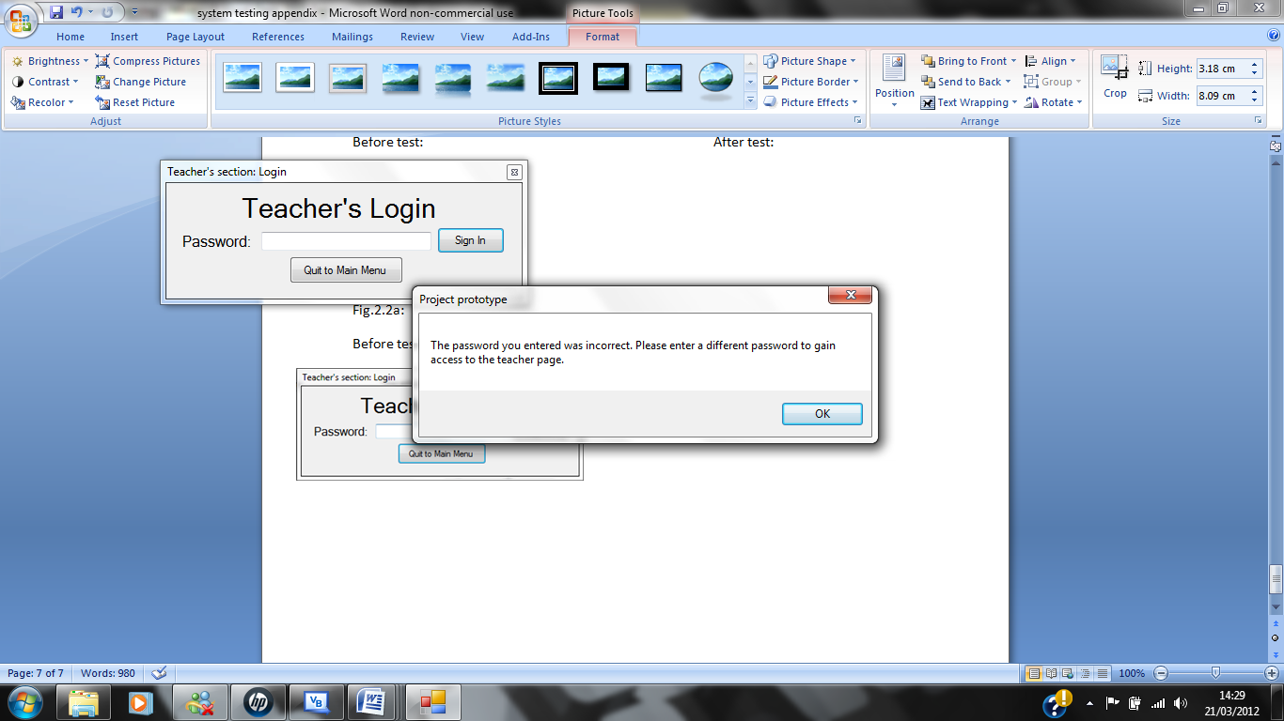Before test: After test:

This is the error message that was displayed after I had pressed the sign in button.

I entered 0 characters and then pressed the sign in button to begin the test.

These screen captures show that test 2.2 using the test data (“”) outlined in the test plan has discovered that the program is working correctly in this case; because the password entered wasn’t accepted and produce an error message.

Fig.2.2b:

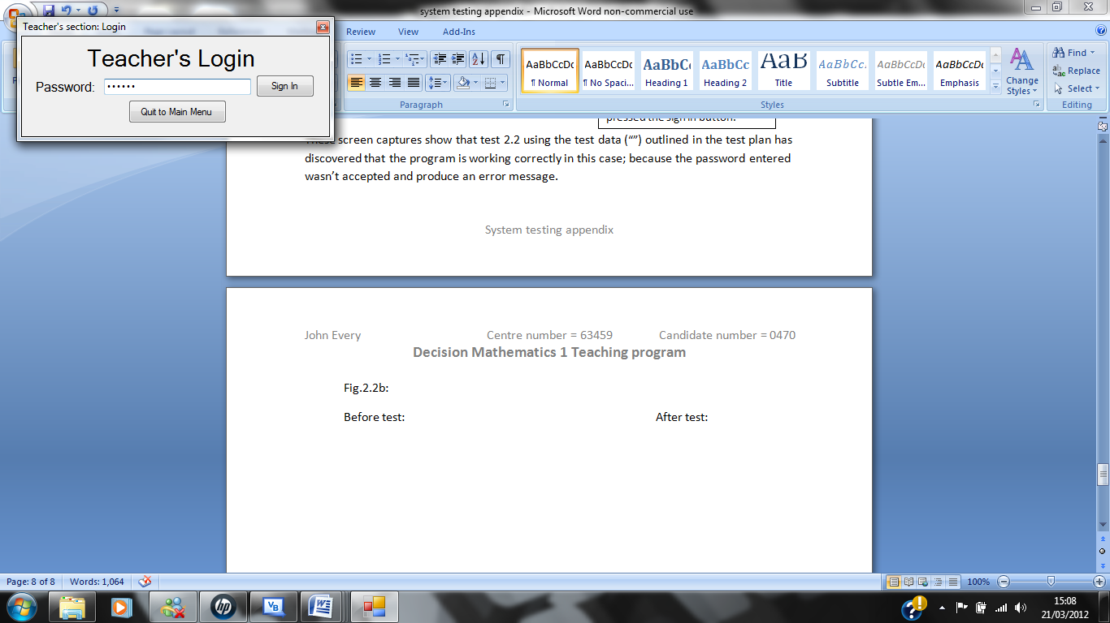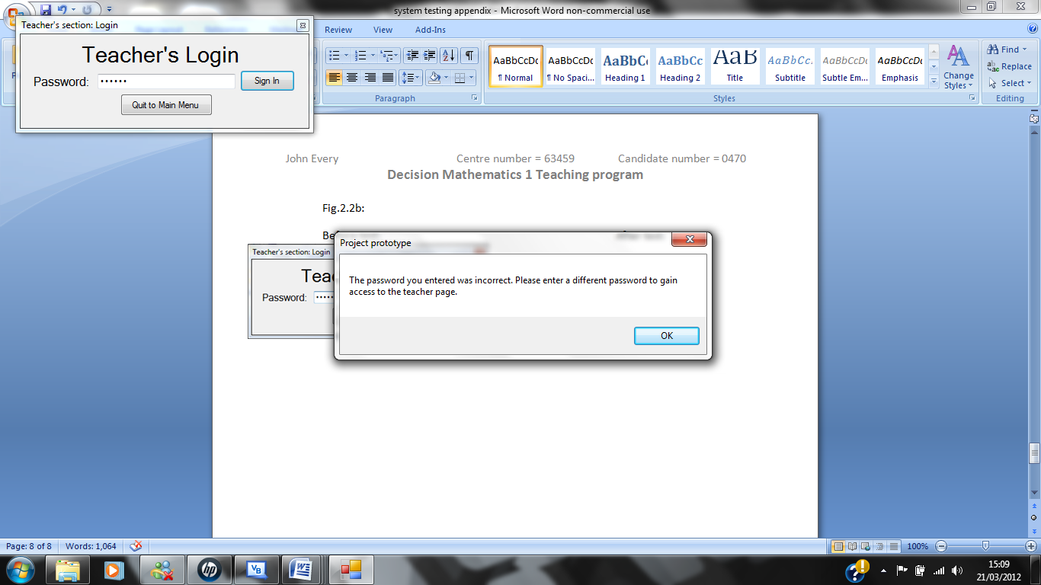Before test: After test:

This is the error message that appeared after I had pressed the “Sign In” button.

I entered the password “Newton” before the test began.

These screen captures show that test 2.2 using the test data (“Newton”) outlined in the test plan has discovered that the program is working correctly in this case; because the password entered wasn’t accepted and produce an error message.

Fig.2.2c:

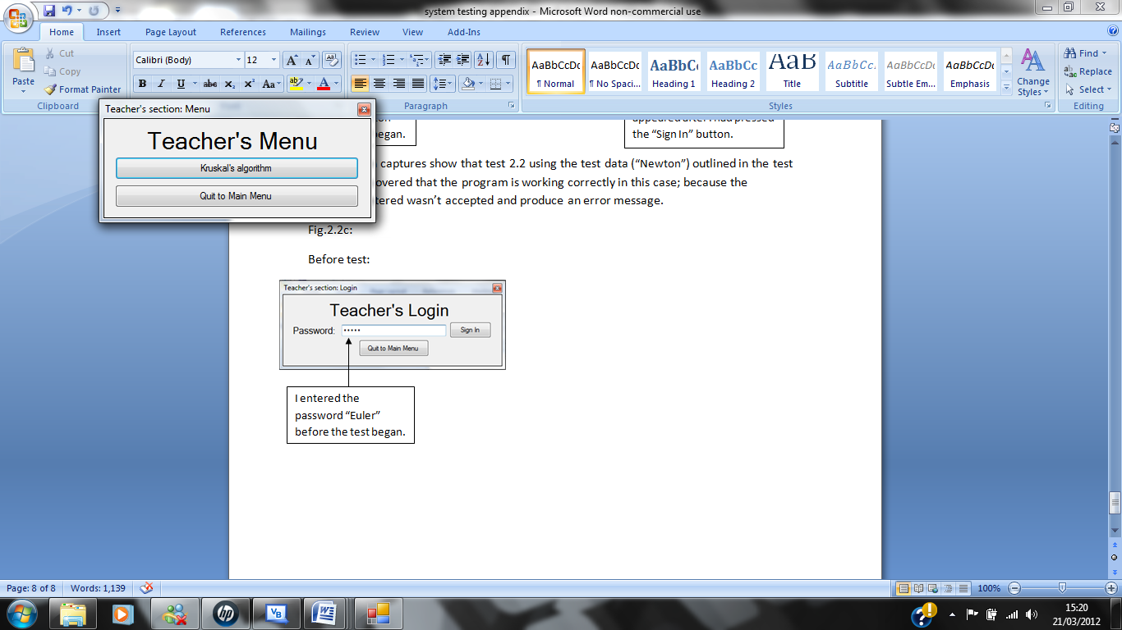Before test:

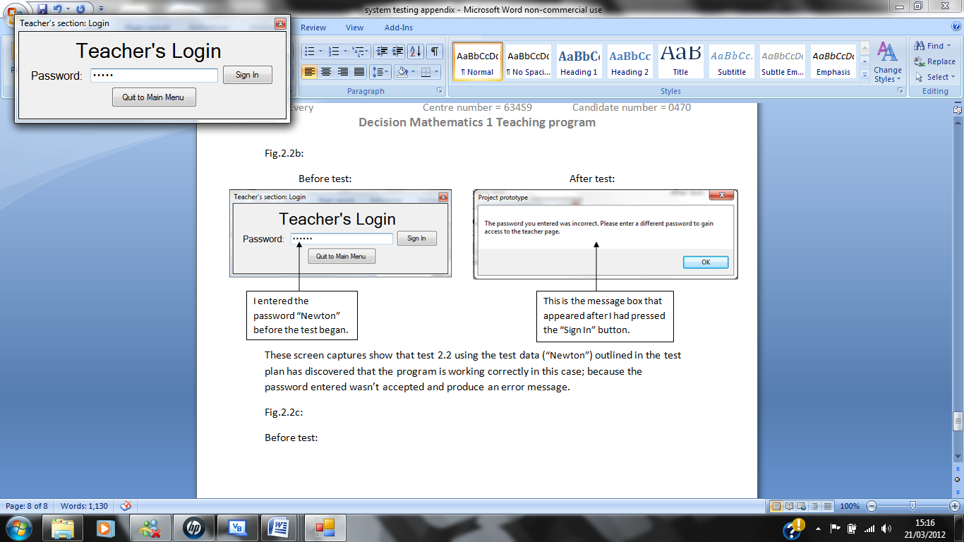

I entered the password “Euler” before the test began.

This is the” Teacher’s section: Menu” page, meaning that the password entered initially was correct.

These screen captures show that test 2.2 using the test data (“Euler”) outlined in the test plan has discovered that the program is working correctly in this case; because the password entered was accepted as it matched the password in the coding; therefore the Teacher’s Menu was displayed.

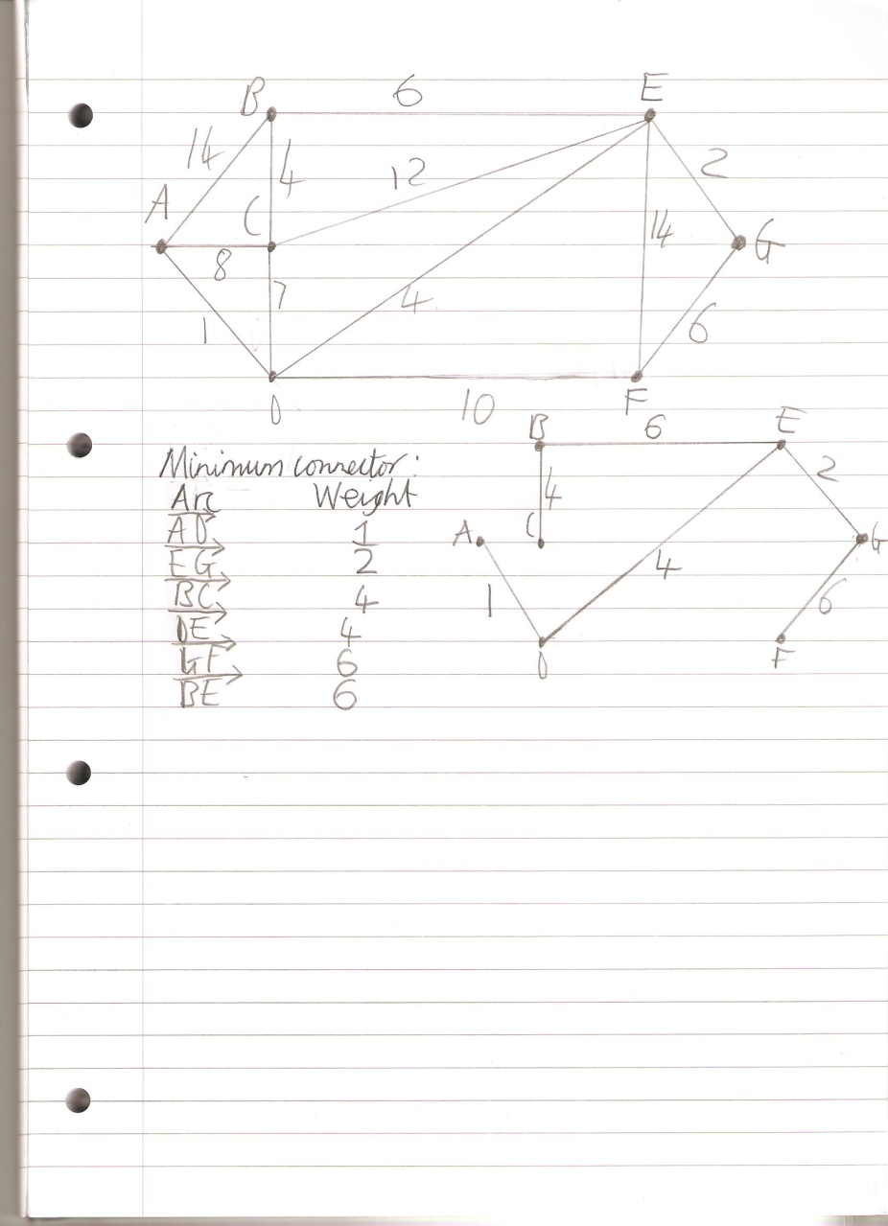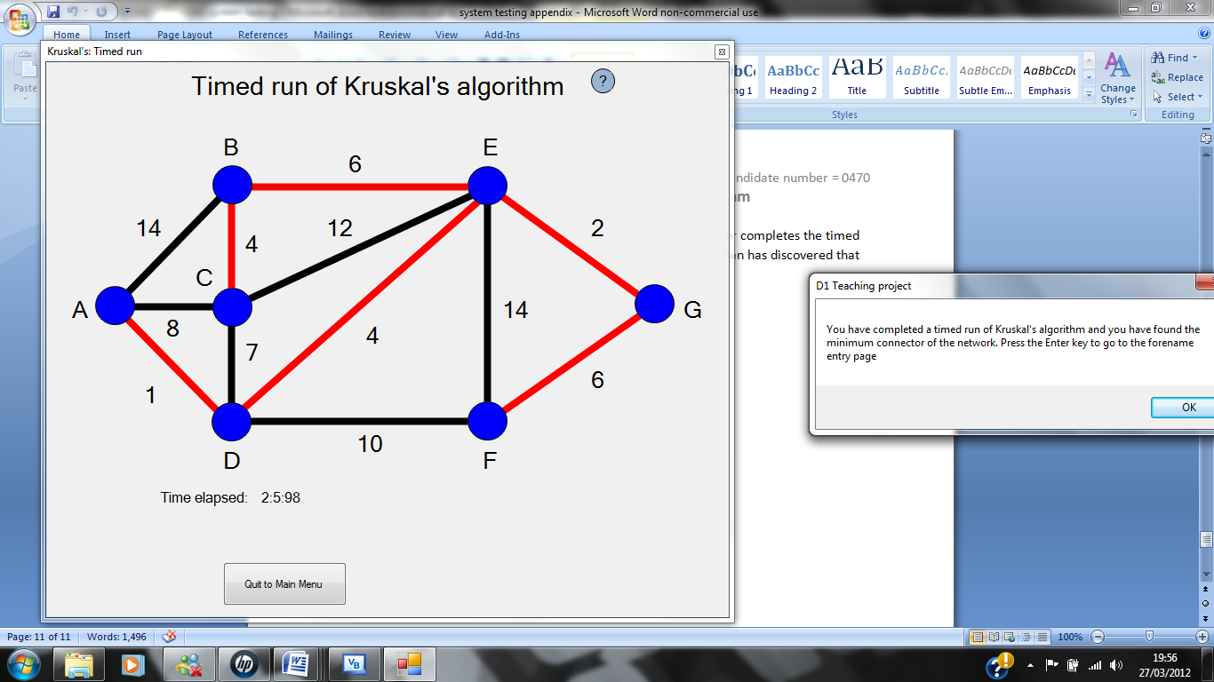Fig.3.3a:

This is the minimum connector produced by the program.

This is me performing the algorithm on the network produced by the program; on paper. The arrow is pointing towards the minimum connector produced by me using Kruskal’s algorithm.

These screen captures show that test 3.3 has discovered that the algorithm is working correctly because the minimum connector produced by my program matches the minimum connector produced by me on paper. Also I have checked with my end user that the working out I did on paper was correct therefore the program produces the correct minimum connector. However when you perform the algorithm on paper you can pick two arcs that have the same arc weight in any order but the program doesn’t do this. Instead it colours the arc out of the two or more same weighted arcs that has the highest position in the array first. For example in this case the arcs DE and BC have the same arc weight this being 4 but because the arc weight that is assigned to DE is at position 7 in the weightings array then it is the next arc to be coloured in the minimum connector and not BC which has position number 5. This will be explained to my users in the user manual so that they know which arc to pick at which time so that this problem doesn’t affect users times too much. This problem is not a big problem because I have spoken to my end user and we have agreed that this is ok. However it could cause confusion to the user because they would have learned in class that it doesn’t matter which arc you chose out of the two or more same weighted arcs to go into the minimum connector first.

Fig.4.1a:

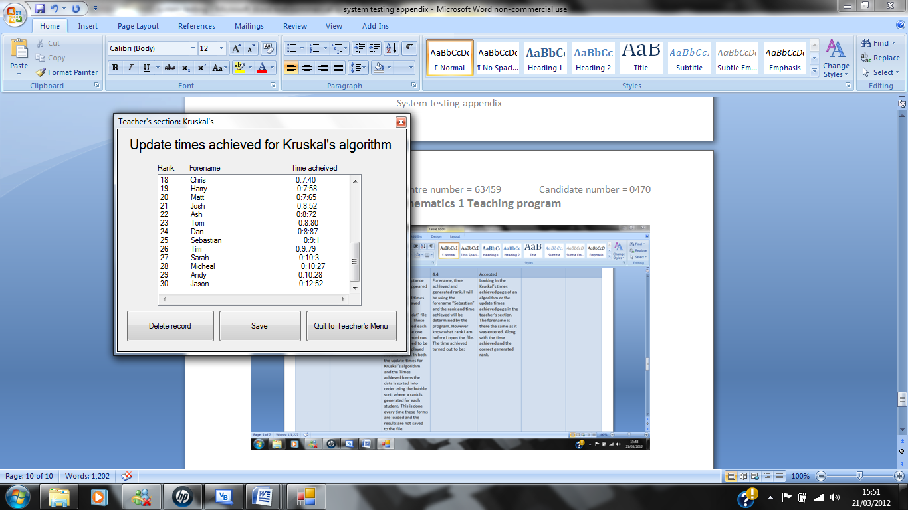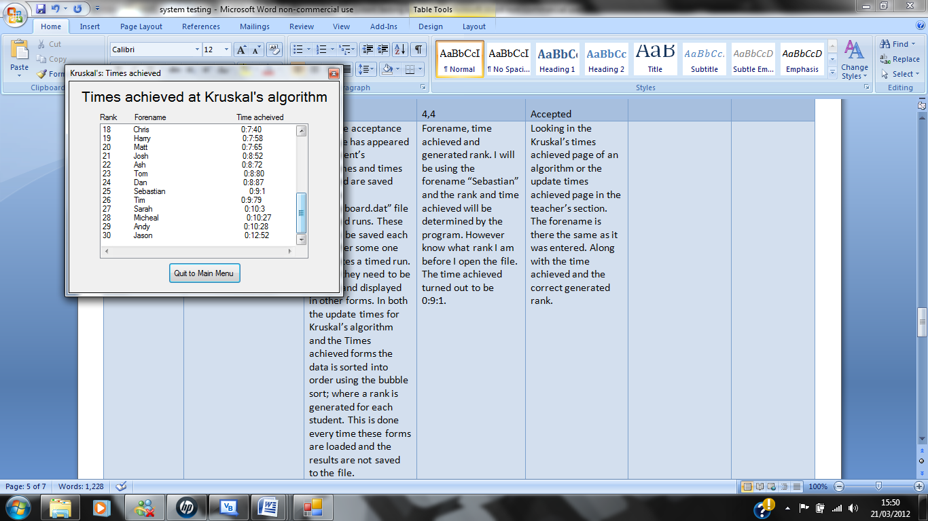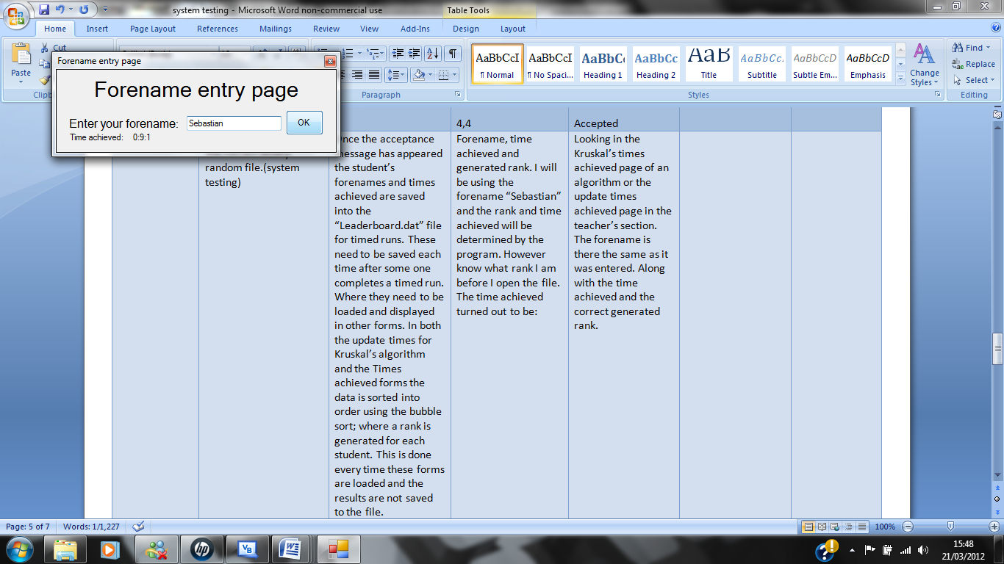Before test: After test:

Before the test I entered the initial test data into the textbox. I began the test when I pressed the “OK” button and the acceptance message had appeared telling me that the record had been saved to the leader board.

Test data displayed on both forms.

These screen captures show that test 4.1 using the test data (Forename = “Sebastian”, Time achieved = 0:9:1) outlined in the test plan has discovered that the program is working correctly in this case because the program has generated a rank of 25 for the test data and displays this entire record in both the times achieved form and the update times achieved form. Therefore the data is being saved into the correct binary random file; this is also shown below: (Screen dump of the contents of the “Leaderboard. dat” file)

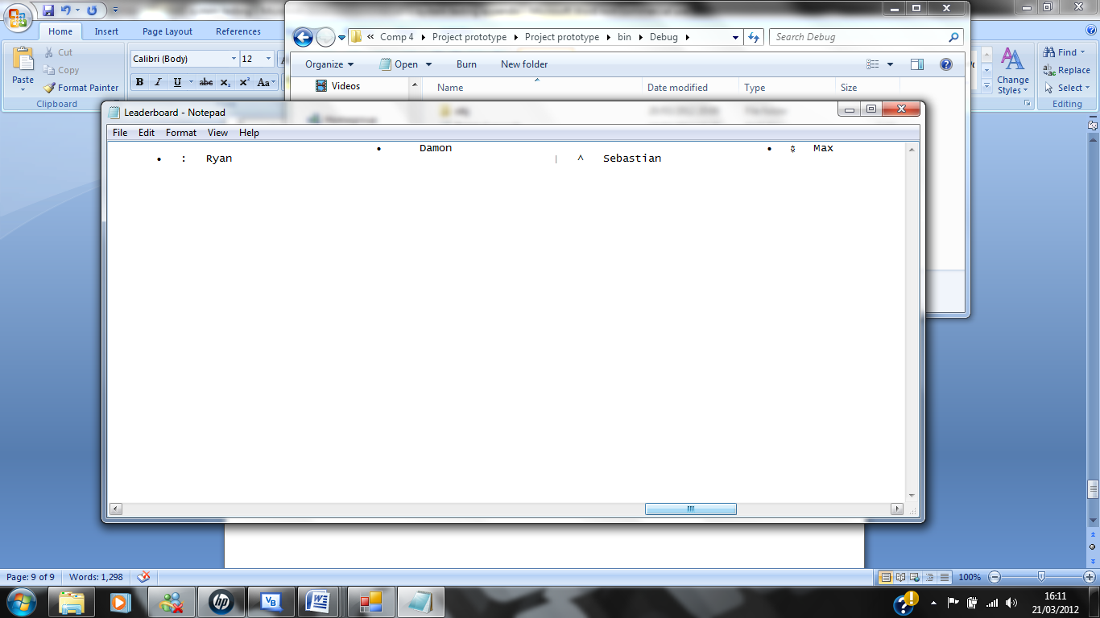

Test data in the file.

Fig.5.1a:

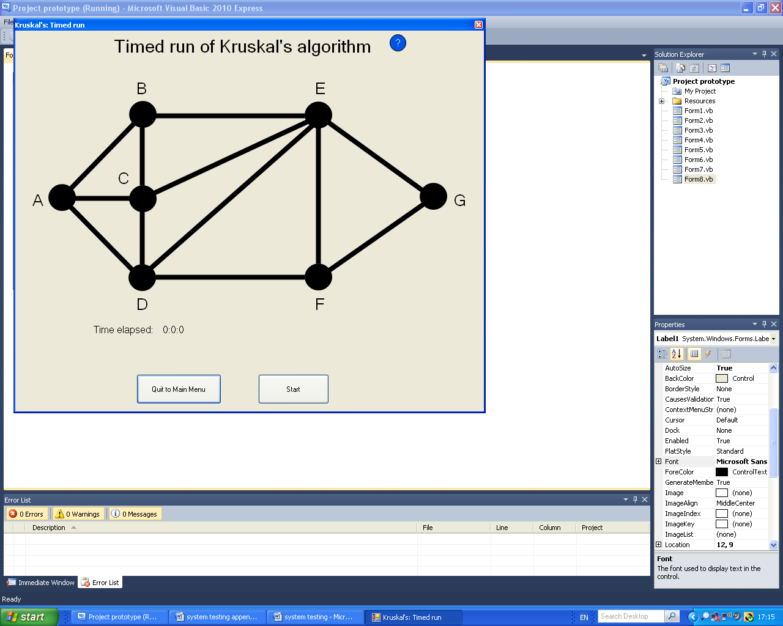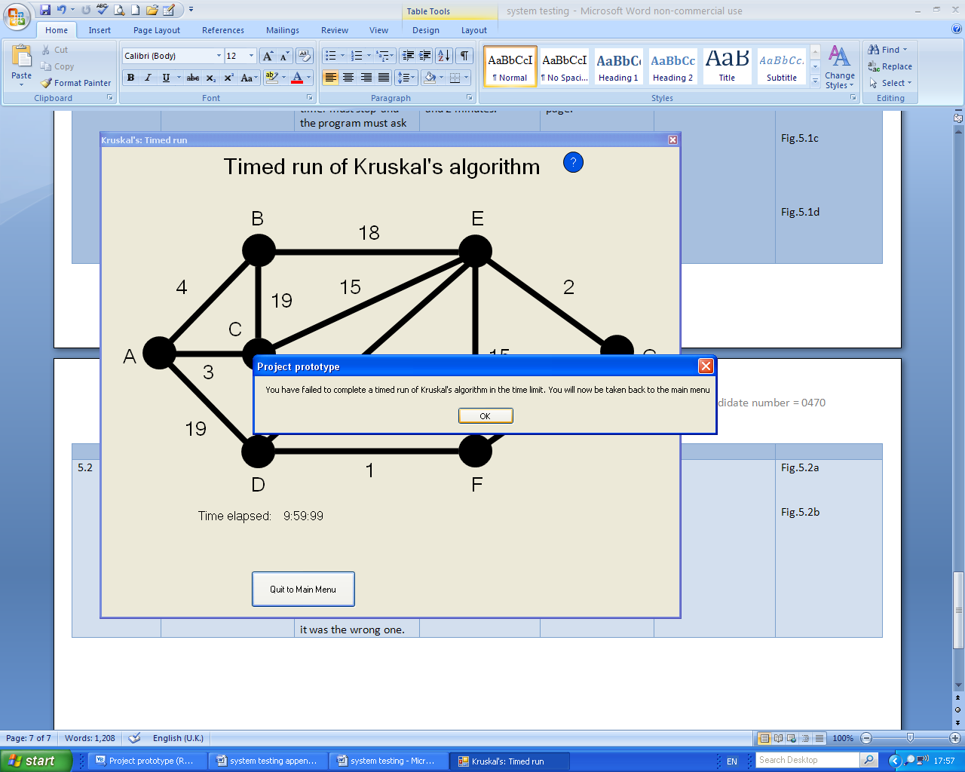 Before test: After test:

These screen captures show that test 5.1 using the test data (Letting the timer run until 9:59:99.) outlined in the test plan has discovered that the program is working correctly in this case.

Fig.5.1b:

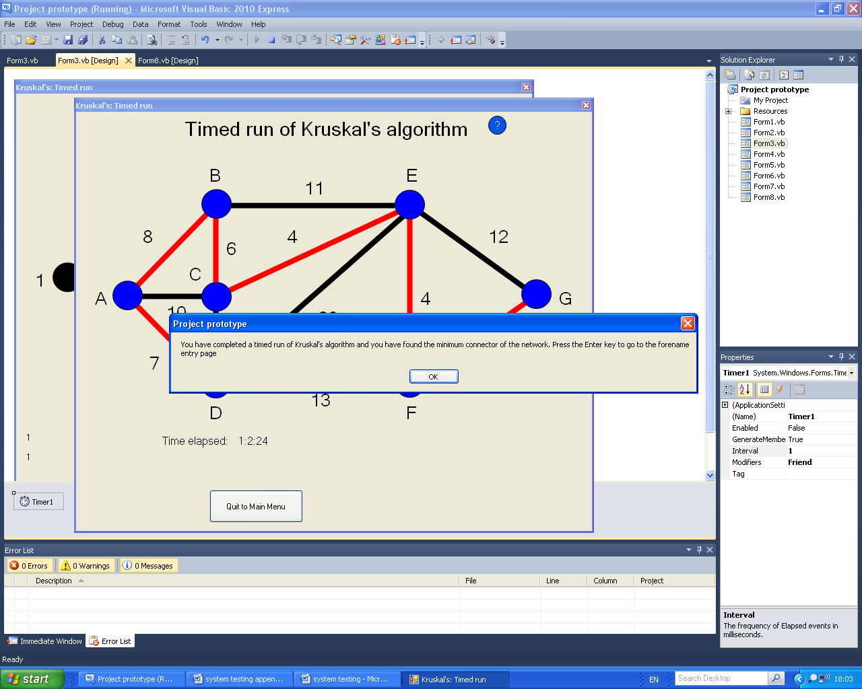 Before test: After test:

These screen captures show that test 5.1 using the test data (The user completes the timed run of an algorithm between 1 and 2 minutes.) outlined in the test plan has discovered that the program is working correctly in this case.